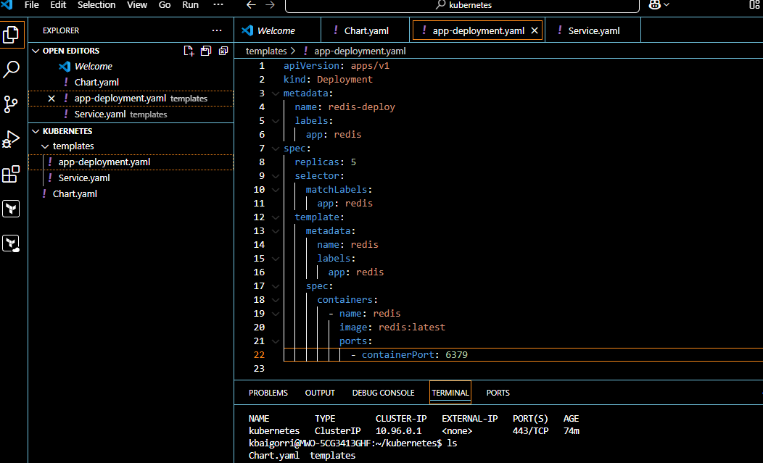

kbaigorri@MWO-5CG3413GHF:~/kubernetes$ **helm install redis .**

NAME: redis

LAST DEPLOYED: Mon Feb 10 16:23:07 2025

NAMESPACE: default

STATUS: deployed

REVISION: 1

TEST SUITE: None

kbaigorri@MWO-5CG3413GHF:~/kubernetes$ **kubectl get pods**

NAME READY STATUS RESTARTS AGE

myapp-pod 1/1 Running 1 (46m ago) 51m

redis-deploy-5c5449fff6-jjdpl 1/1 Running 0 55s

redis-deploy-5c5449fff6-lqpbt 1/1 Running 0 55s

redis-deploy-5c5449fff6-qq772 1/1 Running 0 55s

redis-deploy-5c5449fff6-v7cgn 1/1 Running 0 55s

redis-deploy-5c5449fff6-wv2kf 1/1 Running 0 55s